Problem 1. Thinking about the Central Dogma: DNA, RNA and Protein
**codon references and amino acid references are provided at the end of this document**

Cystic fibrosis is an inherited disease caused by a mutation (or multiple mutations) in the CFTR gene. Different mutations of this gene have been found in cystic fibrosis patients, but the common outcome of these mutations is a dysfunctional CFTR protein. This protein normally serves as a transmembrane protein channel that sits within the cellular membrane of specific epithelial cells to allow passage of chloride and other molecules; without a proper CFTR protein, these epithelial cells malfunction and most famously produce thick/sticky mucus in cystic fibrosis patients, which inhibits respiration among many other symptoms.

You become interested in learning more about cystic fibrosis, so you look up the CFTR gene and its resulting mRNA sequence. You find that the most common mutation is the F508del mutation, where the three nucleotides corresponding to the mRNA sequence below (highlighted red) are deleted in the genome.

5’…AGUGGAAGAAUUUCAUUCUGUUCUCAGUUU…3’

a. What would the template DNA sequence look like if there is an “F508del” mutation in the genome? (please write this in 5’ to 3’ order!)
The UUC will be deleted from the mRNA.
5’ …AGU GGA AGA AUA UGU UCU CAG UUU … 3’

Now find the complement:
3’ …TCACCTTCTTAAAGTACAAGAGTCAAA … 5’

And reverse:
5’ …AAACTGAGAACATGAAATTCTTCCACT… 3’

b. Assuming that the start of the given sequence is in frame with the original start codon (not shown above but upstream of the included sequence), what is the impact of this 3-nucleotide deletion at the amino acid level?
Since exactly one codon was deleted, the remaining reading frames are preserved and we only have the loss of the single amino acid and everything else normal.

You go back to looking at the human genome and zoom in on the CFTR gene, where you notice that there are sections of the DNA sequence that don’t seem to correspond with the full mRNA transcript, as if different sections of the DNA sequence were simply omitted.

c. Why are some sections of the genomic DNA not found in the mRNA transcript that is translated into the CFTR protein?
Because human genes have introns and exons. Cells transcribes the whole region into introns and exons and then splicing removes introns and joins exons together to make the mRNA that gets translated.

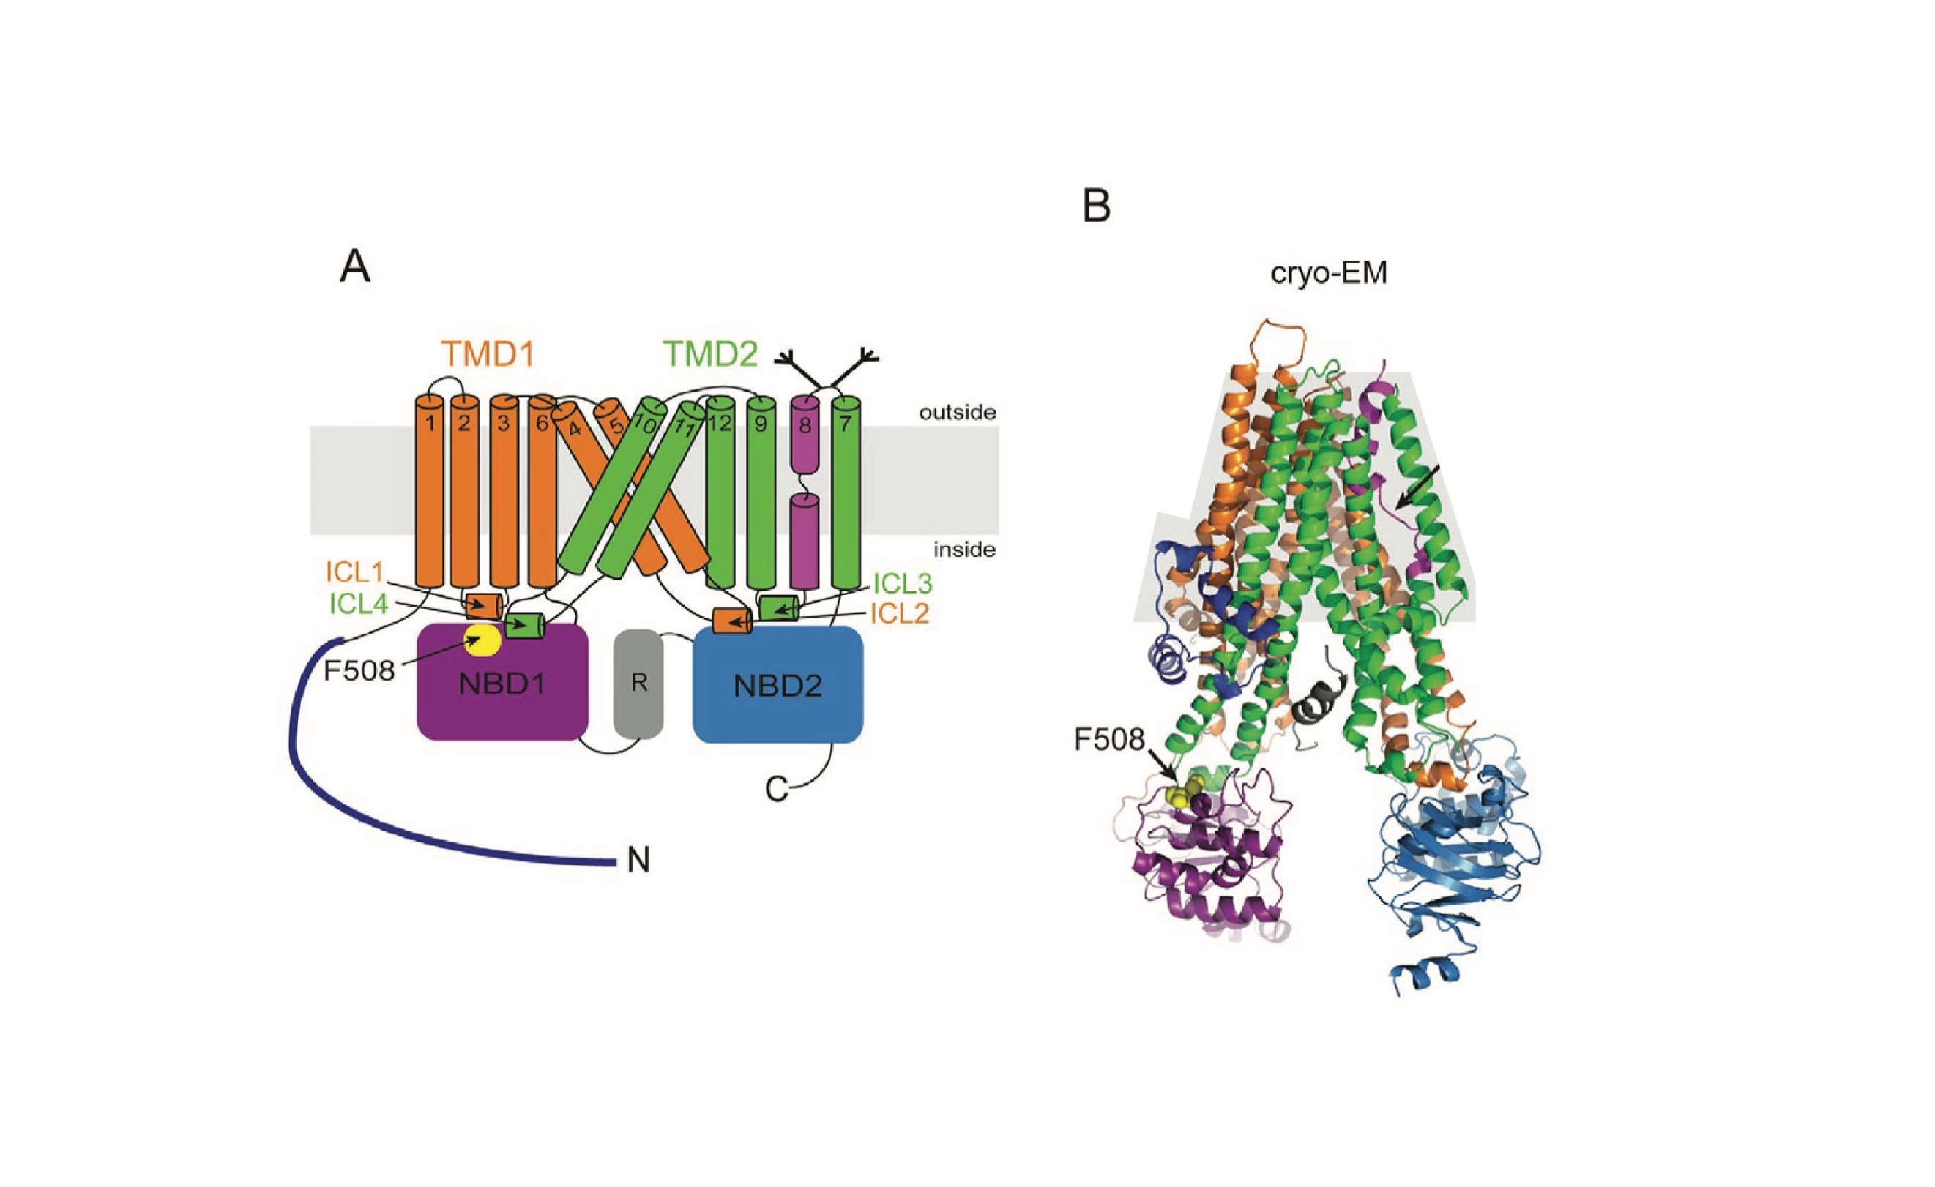
After looking at the DNA and RNA sequences, you now are curious about the actual protein structure of CFTR. After some literature research, you come across this figure of the CFTR protein:

The lefthand figure (A) shows a labeled, simplified version of the righthand cryo-EM visualization of CFTR (B above). The TMD domains (orange and green) are transmembrane domains that sit within the cellular membrane while the NBD domains (purple and blue) bind to ATP, which provides the energy needed to carry out active transport of molecules; proper folding of these domains is crucial for proper processing of ATP. The F508 mutation is highlighted in both figures (yellow dot).

d. What structural components make up the TMD (orange and green) domains? What purpose do these components serve?
The TMD domains are made up of alpha helixes than span the lipid bilayer. They’re hydrophobic on the exterior allowing them to stay inside the cell membrane and they arrange themselves to form a channel for chloride ions to pass through the cell membrane.

e. Considering the different domains of this protein, how do you think F508del mutation is impacting protein structure? (bonus thinking: you can also consider your findings in part b)
F508del is positioned on NBD1, right where it contacts ICL1 and ICL4. Deleting UUC will disrupt the connection between NBD1 and TMD1. Since NBD1 binds to ATP, this messes up the energy transduction needed for transporting the chloride ions as described in part d.

Problem 2. Immune System Strategies

You hear on the news that Chipotle has had another E. coli outbreak. Worried, your friends start to read up on bacterial infections and how exactly our immune system can combat such infections. After searching online, they pick up certain cell types that may be involved, particularly: B cells, macrophages and neutrophils. They start to ask you some clarifying questions since they know you are taking Bi1i:

a. How would E. coli be identified by a B cell?
A B cell identifies E. coli using its BCR to bind to an antigens on the E. coli’s surface. However, only B cells whose receptor shape is complementary to that particular E. coli antigen will recognize it. This is part of adaptive immunity.

b. How would E. coli be identified by a macrophage or neutrophil?
Macrophages or neutrophil have TLRs that recognize broad molecular patterns across pathogens as part of the innate immune system, some of which could relate to E. coli.

Your friends find B cells fascinating and are especially excited about the cell surface receptors you described in part a. However, they soon make a comment:
“Wow, somehow our bodies know which bacteria might be harmful, so we pre-program B cells to make cell surface receptors that are specific to each harmful bacteria!”

You realize that there has been a bit of a misunderstanding of how B cells are able to generate greater diversity of their cell surface receptors.

c. Describe how you would explain the mechanism by which B cells can create many different receptors that can recognize different potential threats. Is this process “pre-programmed” like how your friend described?
B cells create receptor diversity primarily through VDJ recombination. Basically, in developing B cells, the V, D, and J (heavy chain) and V, J (light chain) DNA segments are randomly chosen and recombined. Then enzymes cut and rejoin DNA to make a unique variable region. Diversity is thereby increased due to imprecise joining and random nucleotide additions and removals. This is actually the opposite of preprogramming as there’s natural randomness and selection.

Finally, your friends understand V(D)J recombination after hearing your wonderful explanation above. They have one last follow-up question:

d. So cell surface receptors are really important for B cells, macrophages, and neutrophils – basically all of innate and adaptive immunity. What does cell signaling actually do within these cells? (You don’t have to detail a specific signaling cascade, but describe at least one downstream impact of cell signaling and the general way it does so)
Cell signaling acknowledges the fact that something has been detected and emits a respective cellular response by changing which proteins are active and which genes get expressed. An example is for B cells. First, a signal activates transcription factors that move into the nucleus and turn on specific genes. For a B cell genes could start continuously dividing or have a cell start creating lots of antibodies.

Problem 3. Experimental Techniques Applied

Going back to Human Papillomavirus (HPV), a recent study investigated the role of HPV in bladder cancer. They hypothesized that patients with bladder cancer have a higher probability of having high-risk HPV strains. Consequently, researchers analyzed bladder tissue from six different patients diagnosed with bladder cancer.

a. Compare how viral infection is harmful to hosts vs. how cancer is harmful to hosts. How might viral infection impact cancer development?
Viral infections penetrate and hijack cells stopping their function and turning them into mechanisms to produce more viruses and replicate. This can also cause apoptosis and subsequent tissue damage.
Cancer results in uncontrolled cell division with tumors that disrupt organ function and steal resources from the body.
Viral infections may impact cancer development by inactivating the body’s cancer prevention mechanisms (i.e. mechanisms that regulate tumors or cell division).

HPV is a DNA virus, meaning its genetic material is DNA (as opposed to being an RNA virus like with SARS-CoV-2), so researchers tested for presence of high-risk HPV strains (HPV18, HPV39, HPV45, HPV59) by performing PCR reactions. Within the PCR reaction, they included primers for all 4 high-risk HPV strains. The primers used in this study targeted conserved regions of the viral genome that vary sufficiently to distinguish the different HPV types. Additionally, primers targeting a highly-expressed housekeeping gene were included in each PCR reaction (described further after part b).

b. Explain how this PCR test will detect the presence of HPV18 in bladder cancer patients. Can the test detect if the patient has HPV18 and HPV45?
The PCR test detects HPV18 using primers. If HPV18 DNA is present, then these primers will be extended to create many copies of a DNA segment.

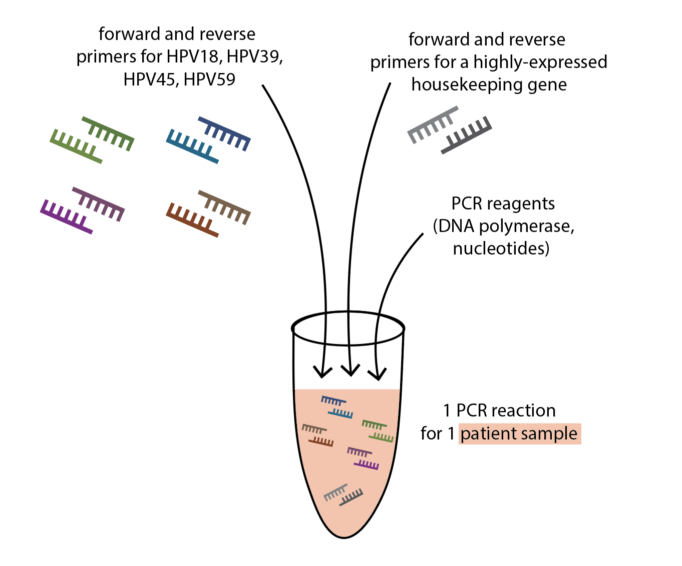
To visualize the results of the PCR test, researchers ran their PCR products on a gel (shown below). The first lane includes a DNA ladder to check the size of the PCR fragments, followed by a negative control lane and a positive internal control lane. The negative control was a PCR reaction that only contained PCR reagents – there was no sample with genetic material included. The positive internal control contained a known housekeeping gene sequence; this control was to ensure that the PCR reagents were functional and actually working. To reiterate, each PCR reaction (for patient samples and for controls) contained primers targeting the 4 strains of HPV along with primers targeting this highly expressed housekeeping gene (schematic included to the right for clarity).

After the ladder and control lanes, 4 samples known to contain the genetic material of the 4 high-risk HPV strains were next included in the gel. Finally, ID134-138 represents the six different patient samples.
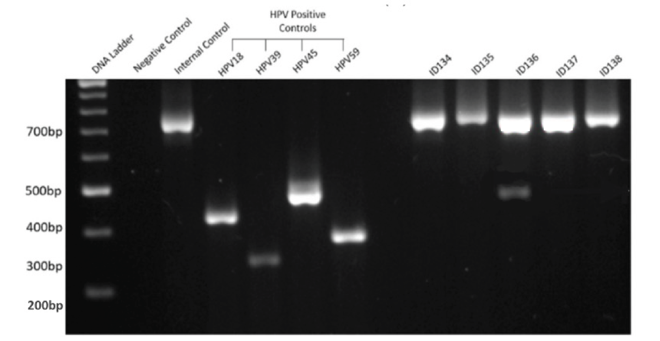
c. PCR amplifies DNA from any set of primers that finds a target. How does gel electrophoresis help to distinguish between the presences of the four HPV positive controls? Looking at the four HPV positive control lanes, what does this tell you about the positions of the different primer pairs on the different HPV genomes?
Gel electrophoresis helps distinguish between the presences of the four HPV positive controls by separating the DNA fragments by size, such that smaller fragments run further down the gel and larger ones stay closer to the top.
Given that each HPV has a different level of a bp band, the distance between the forward and reverse primers is different for each HPV strain. For HPV18, the primers bind close yielding a short DNA fragment; for HPV45, the primers bind further apart, which results in a larger fragment of DNA.

d. For each of the 6 patient lanes (ID134-138) interpret what the gel result above indicates. Do any patients have any high-risk strain of HPV?
Every patient lane shows a band at about 700–750 bp. There are normal/the control (confirms that the PCR reaction worked properly for each sample). However, ID136 has a band at about 500bp which is positive for HPV45, a high risk strain of HPV.

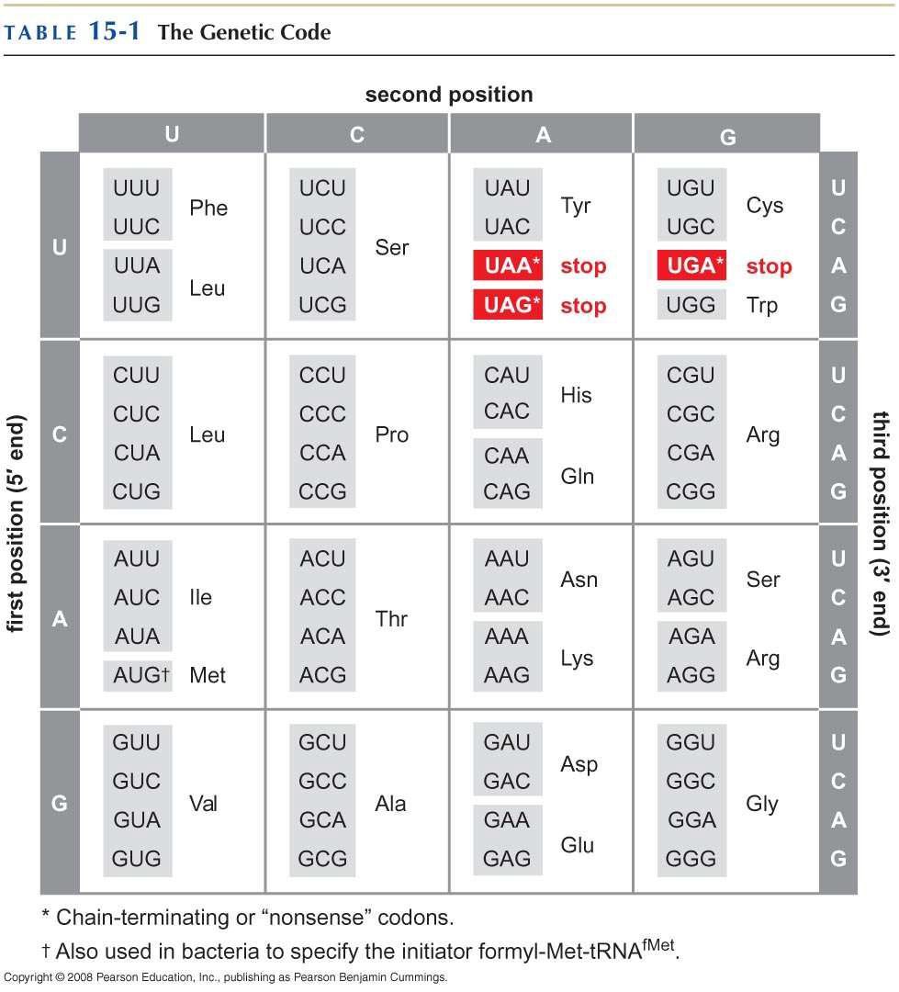

** note: selenocysteine is NOT a separately encoded amino acid!!
** note: pKa = measure of a molecule’s acidity where low pKa indicates strong acidic properties while high pKa indicates weak acidic properties

